**Amazon Simple Notification Service**

1. Create a Topic name

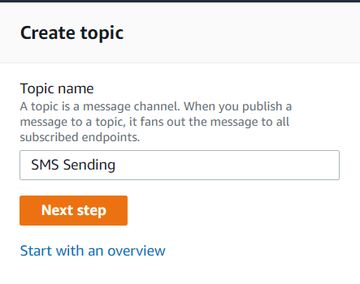

1. Now go to progess

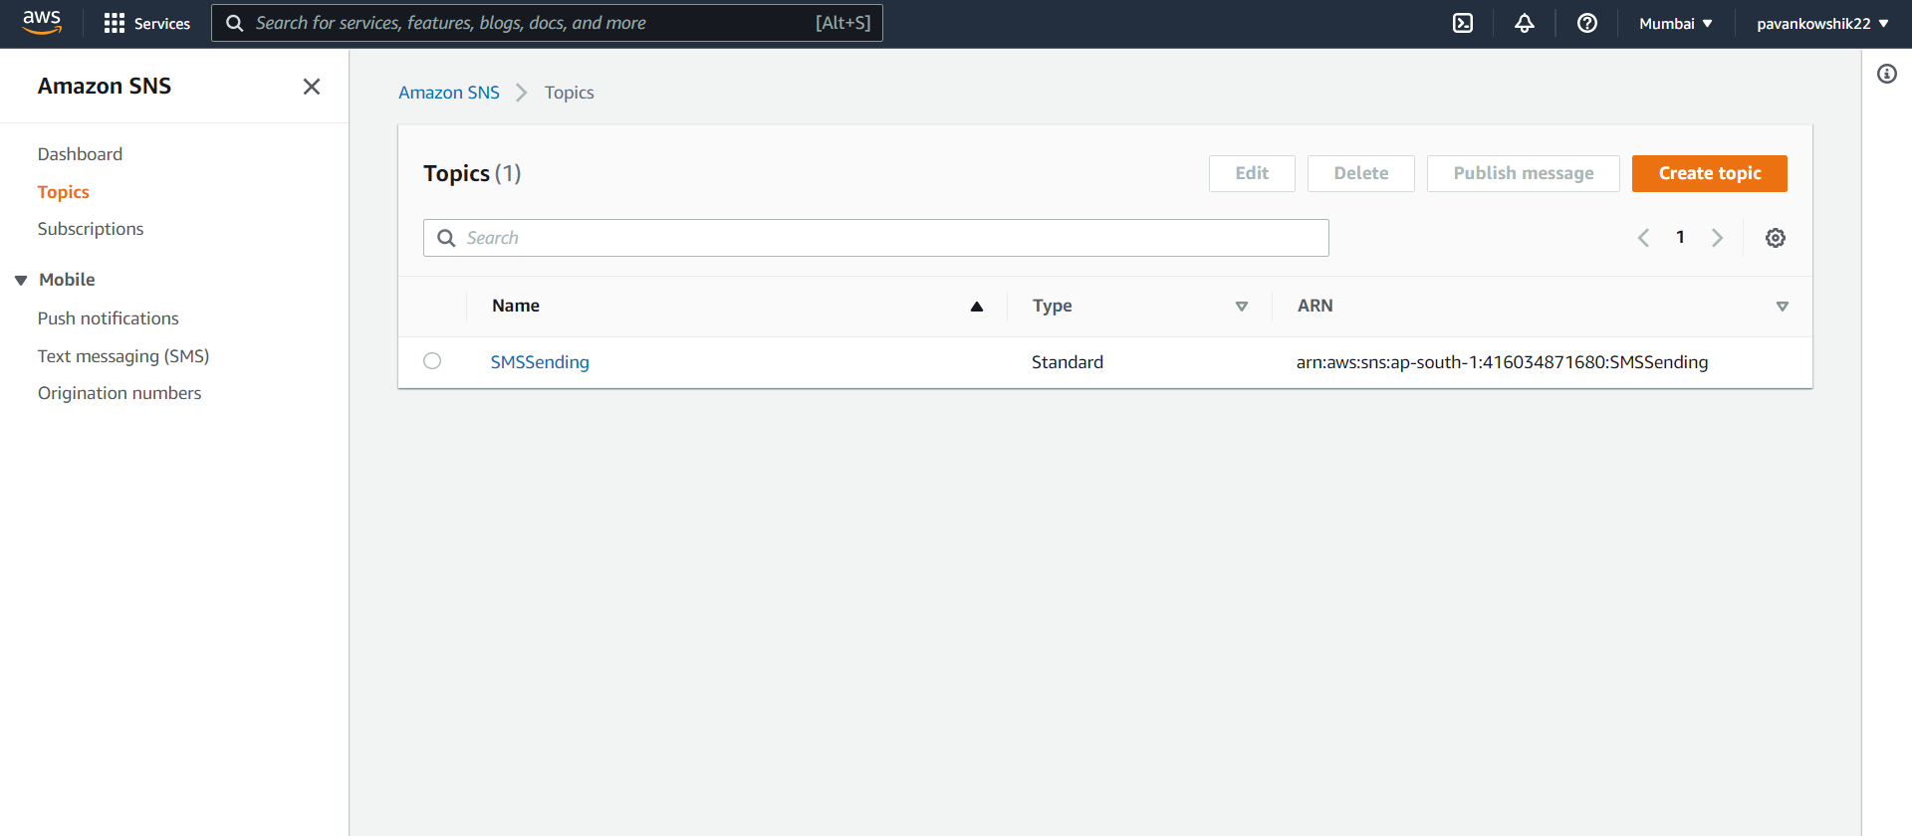

1. Click on Create Subscription

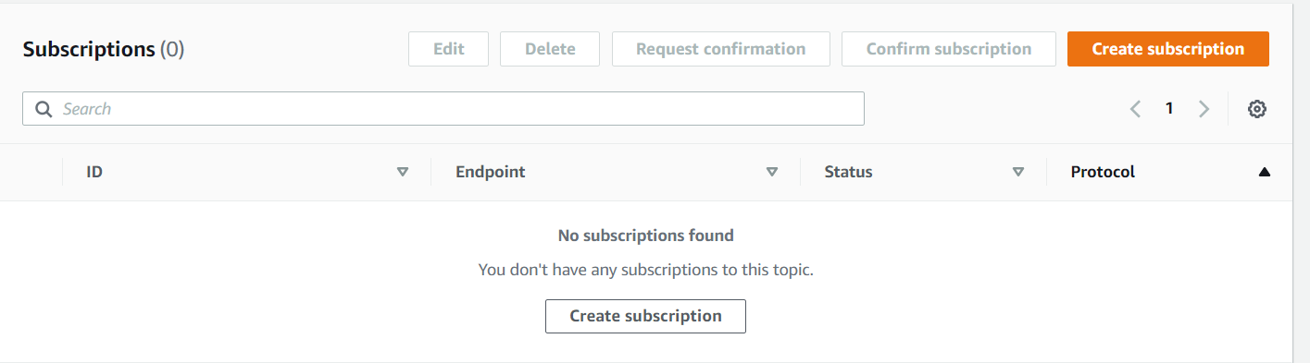

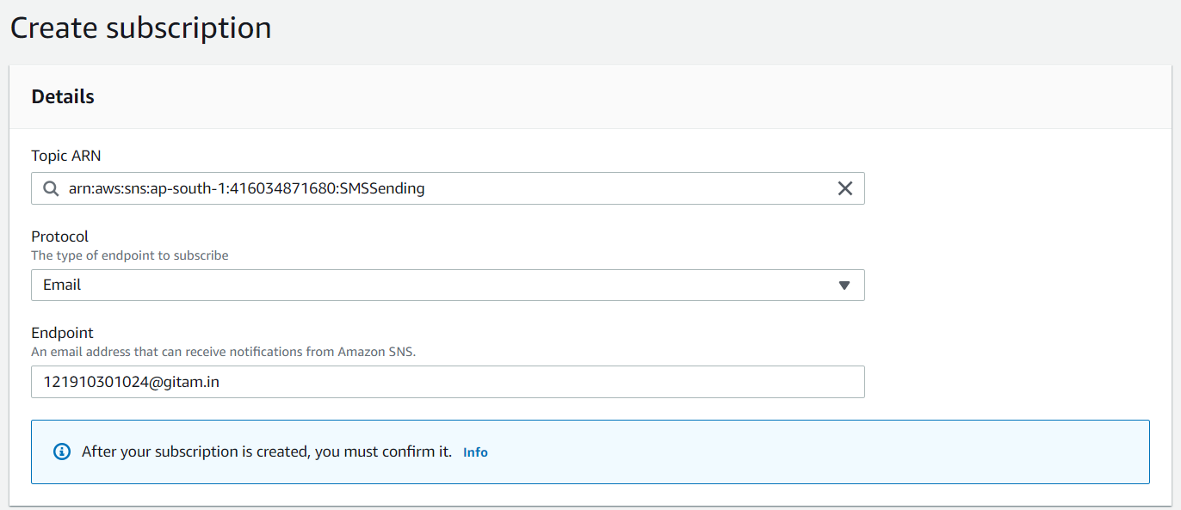

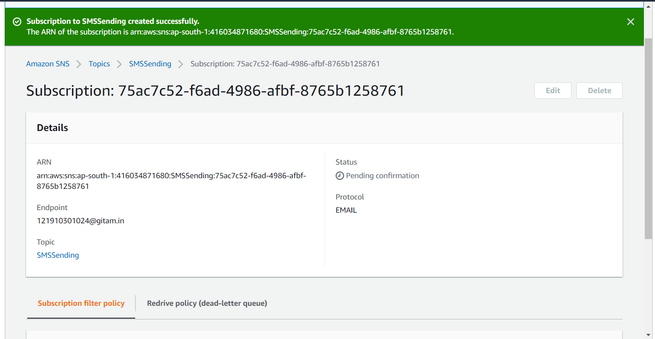

1. Confirm the Subscription

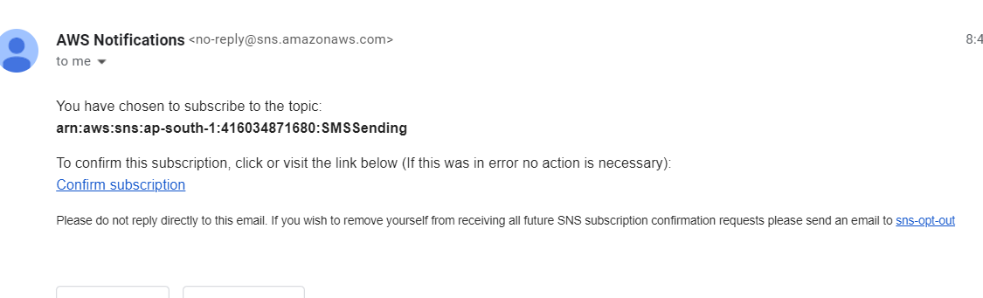

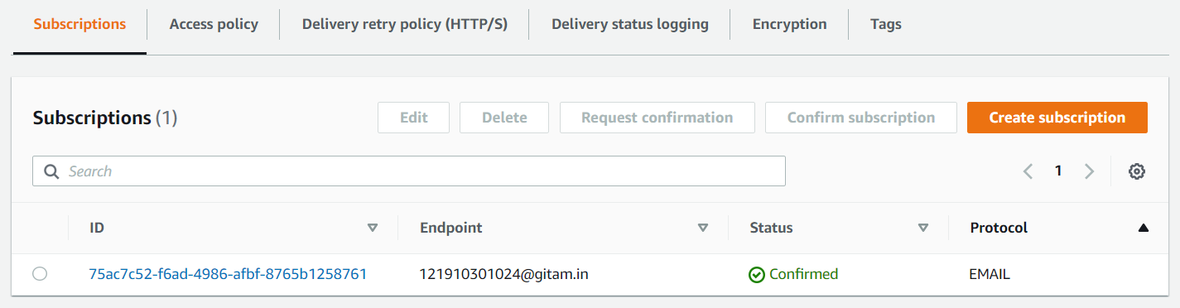

1. Now we can publish the message

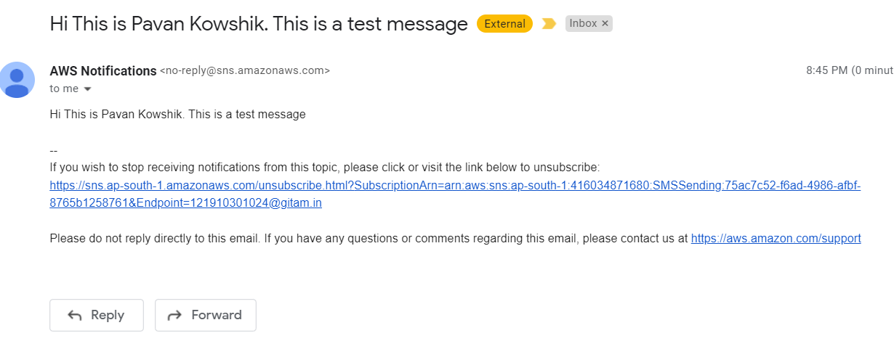

## [CloudWatch](https://ap-south-1.console.aws.amazon.com/cloudwatch/home?region=ap-south-1) or [Amazon EventBridge](https://ap-south-1.console.aws.amazon.com/events/home?region=ap-south-1)

1. Click on Create Event

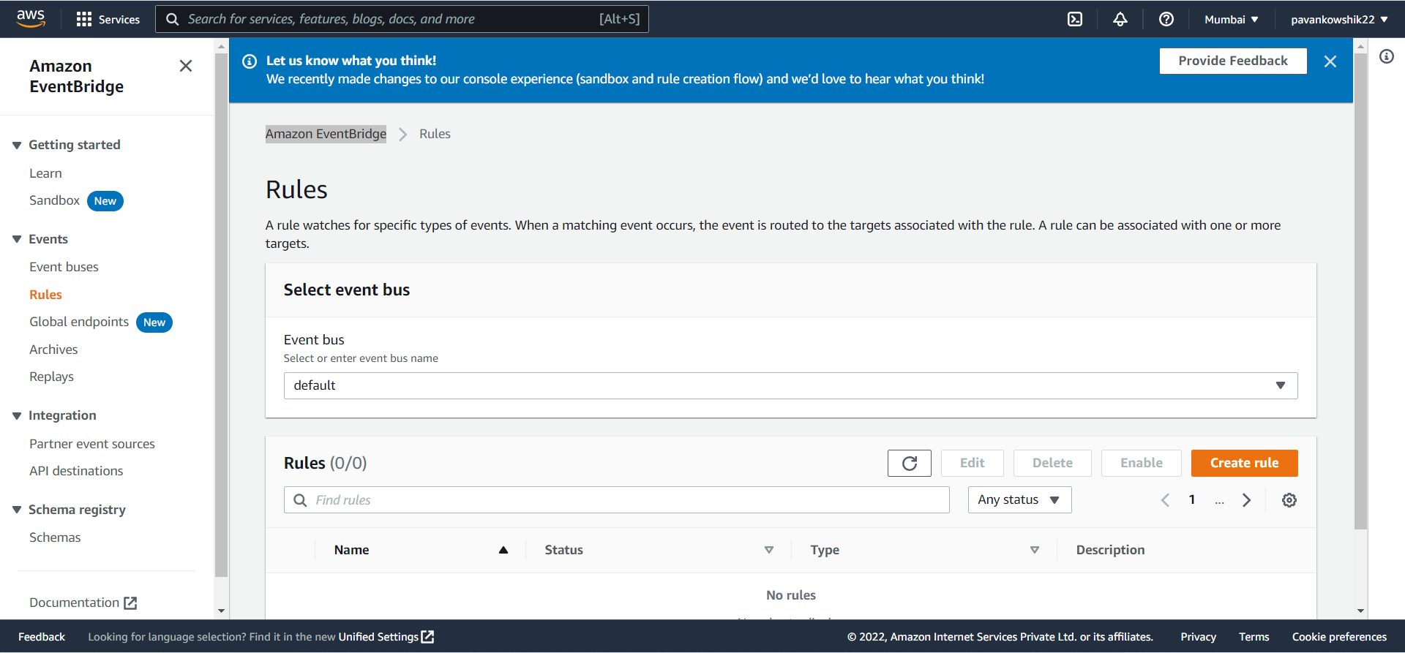

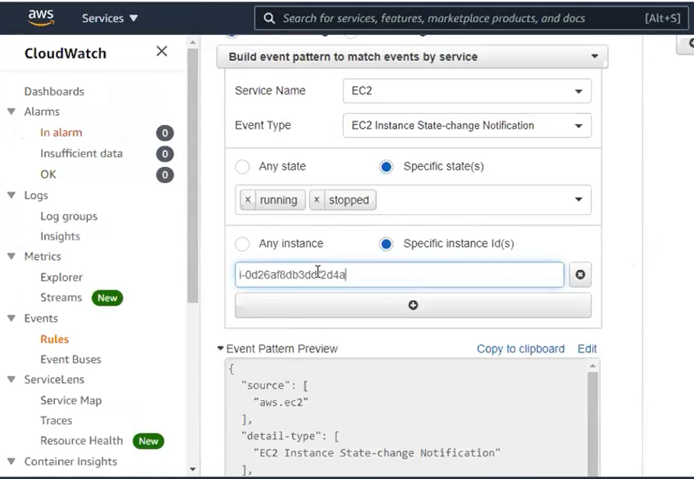

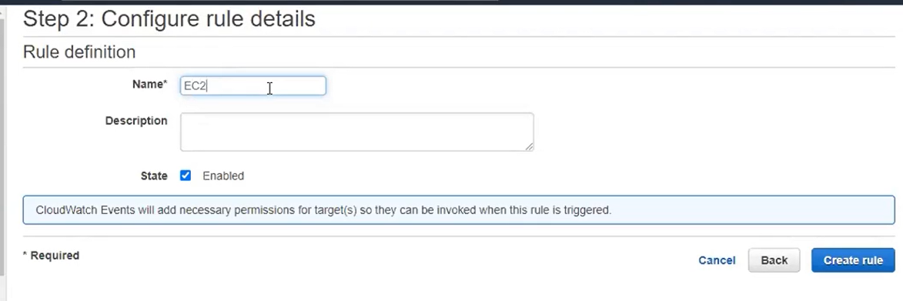

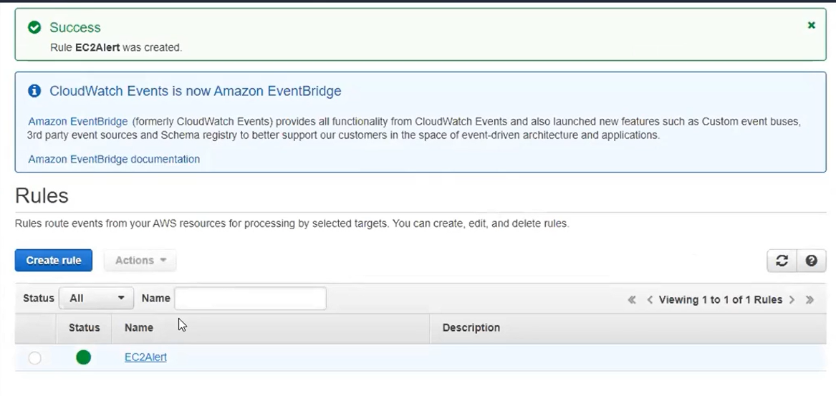

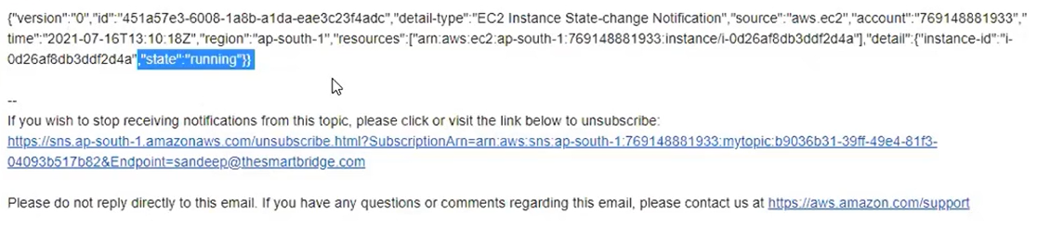

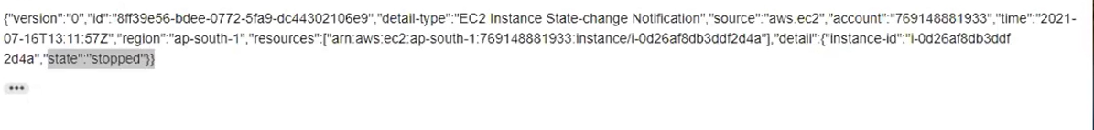

AT LAST DELETE ALL THE INTANCES